Source https://www.getyourguide.com/barcelona-l45/barcelona-catalan-paella-cooking-class-t442495/?ranking_uuid=4a1f21bb-bb30-4358-aa19-af23d2e96bc5
__________________________________________________________

Barcelona Traditional Paella Cooking Experience
__________________________________________________________
★★★★★ 4.5/5 20 reviews

Add to wishlist ♡

__________________________________________________________

2.5 Hours | €115 per person

🏕  Image | 🏕  Image | 🏕  Image | 🏕  Image | 🏕  Image | 🏕  Image

__________________________________________________________
Experience Overview
Step into Barcelona’s culinary world with a hands-on workshop dedicated to preparing authentic Catalan-style paella. Guided by professional instructors, you’ll learn traditional techniques, explore regional ingredients, and uncover the cultural roots of Spain’s iconic rice dishes. This interactive experience combines gastronomy, storytelling, and practical cooking skills — finishing with the best reward of all: tasting your own creation.
__________________________________________________________
Tour Snapshot
- Duration: 2.5 hours
- Meeting Point: Carrer de Jaume Puigvert 13B, Barcelona
- Group Size: Small group experience
- Accommodation: Not included (activity only)
- Languages Available: Catalan, English, Spanish
- Private Guide: Included (culinary instructor)
- Transportation: Not included
- Season: Available year-round
__________________________________________________________

Check Dates & Availability

Select participants: (Age 99 and younger) - 1 +

Choose date:
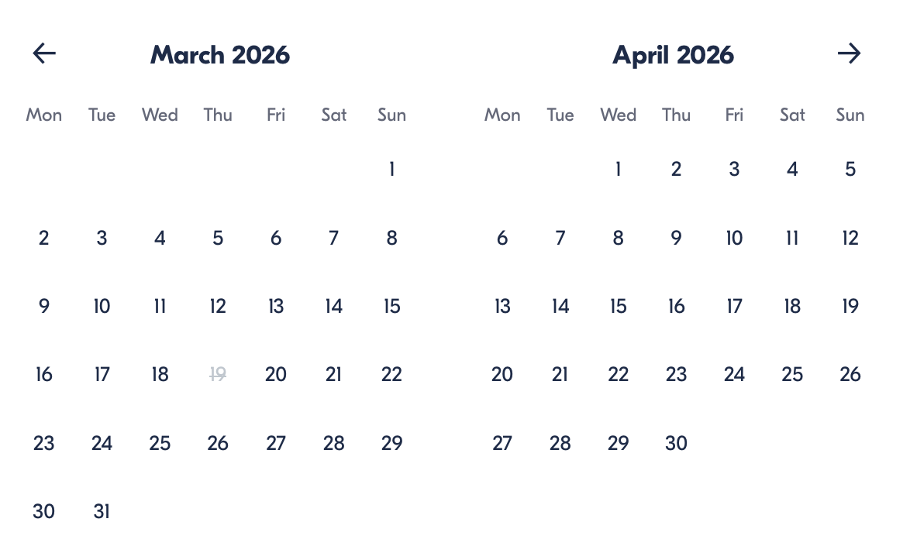

Check Availability

opens:

Participants: 1 March 16, 2026

Barcelona Traditional Paella Cooking Workshop

- Duration: 2.5 hours
- Offered in: English, Spanish, Catalan
- Starts at: Confirmed after booking

Cancellation:

- Cancel more than 24 hours before start → Full refund
- Cancel within 24 hours → No refund

Price breakdown: 1 Participant × €115

Total: €115

The total price includes all taxes and fees.

Add to cart Book now

__________________________________________________________
Key Highlights
- Prepare authentic Catalan paella using traditional arrossada technique
- Learn regional culinary traditions from expert instructors
- Cook inside a professional kitchen near Park Güell
- Enjoy a small-group setting for personalized guidance
- Taste your finished dish after the session
__________________________________________________________
Experience Plan

Cooking Workshop Session
Arrive at a charming culinary studio near Park Güell, where your instructor welcomes you into a historic-style kitchen full of character. During the session, you’ll be guided step by step through the preparation of traditional Catalan paella, learning authentic methods passed down through generations. Along the way, you’ll discover insights about regional gastronomy and cooking culture. Once the dish is complete, you’ll sit down to enjoy your handmade meal in a relaxed atmosphere.
Accommodation:
Not included (workshop experience only)
__________________________________________________________
What’s Included
- Instructor-led cooking class
- Hands-on preparation of traditional Catalan paella
- Ingredients and cooking equipment
- Small-group learning environment
- Taxes and service fees included
__________________________________________________________
Not Included
- Transport to or from the venue
- Extra food or drinks beyond the class
__________________________________________________________
Travelers Who May Prefer Another Experience
- Mobility limitations: Kitchen space may be compact and involve standing.
- Food allergies: Guests with dietary restrictions should confirm suitability before booking.
- Very young children: Designed primarily for adults or older participants comfortable in a cooking environment.
__________________________________________________________
Important Experience Information
- Duration: Approximately 2.5 hours total.
- Location: Professional kitchen close to Park Güell.
- Group Format: Small groups allow individual attention.
- Skill Level: Suitable for beginners and experienced cooks.
- Arrival: Please arrive a few minutes early to ensure a timely start.
- Atmosphere: Informal, interactive, and educational culinary setting.
- Assistance: Staff remains available throughout the workshop for guidance.
__________________________________________________________

Cancellation Policy
- Cancel more than 24 hours before start → Full refund
- Cancel 24 hours or less before start or no-show → No refund
Price may vary if participant numbers change.
Refunds are processed after cancellation confirmation.
__________________________________________________________
Guest Reviews

Overall rating  4.5/5  ★★★★★  Based on 20 reviews | Review summary  Guide 4.5/5  Transportation 4.6/5  Service 4.7/5  Organisation 4.5/5

Filter  - All traveller types  - Couples  - Group of friends  - Families  By star rating  - All star ratings  - 5 stars  - 4 stars  - 3 stars  - 2 stars  - 1 star | Search reviews (e.g., guide)  Sort by:  - Top picks  - Latest reviews  - Best ratings  - Lowest ratings
__________________________________________________________
★★★★★
Clara M. — Italy
Such a fun culinary experience! The class was engaging, informative, and the paella we cooked tasted incredible. Perfect for food lovers visiting Barcelona.
★★★★★
Jorge L. — Spain
Great workshop with knowledgeable instructors and authentic techniques. I learned a lot about local cuisine and really enjoyed the hands-on format.
★★★★☆
Anna K. — Germany
Lovely cooking class in a charming kitchen. The space was a little tight, but the experience itself was fantastic and well organized.
See more reviews
__________________________________________________________

Meta tags

Page - Barcelona Traditional Paella Cooking Experience

Title: Barcelona Traditional Paella Cooking Experience | Travellio Global
Description: Learn to cook authentic Catalan paella in Barcelona with a hands-on culinary workshop led by expert instructors. A delicious cultural experience by Travellio Global.
H1 — Barcelona Traditional Paella Cooking Experience
__________________________________________________________

